Assignment no-1

1.Program to create an array of size 10 and check whether the no. is present or not:

#include<stdio.h>

void main()

{

    int i,num;

    int a[5];

    printf("Enter the array elements:\n");

    for(i=0; i<5; i++){

        scanf("%d", &a[i]);

    }

    printf("array elements are:\n");

    for(i=0; i<5; i++){

        printf("%d\n", a[i]);

    }

    printf("Enter the number which you want to search:");

    scanf("%d",&num);

    if(num == a[i]){

       printf("Number is present.");

    }

    else{

        printf("Number is not present.");

    }

}

**Output:**

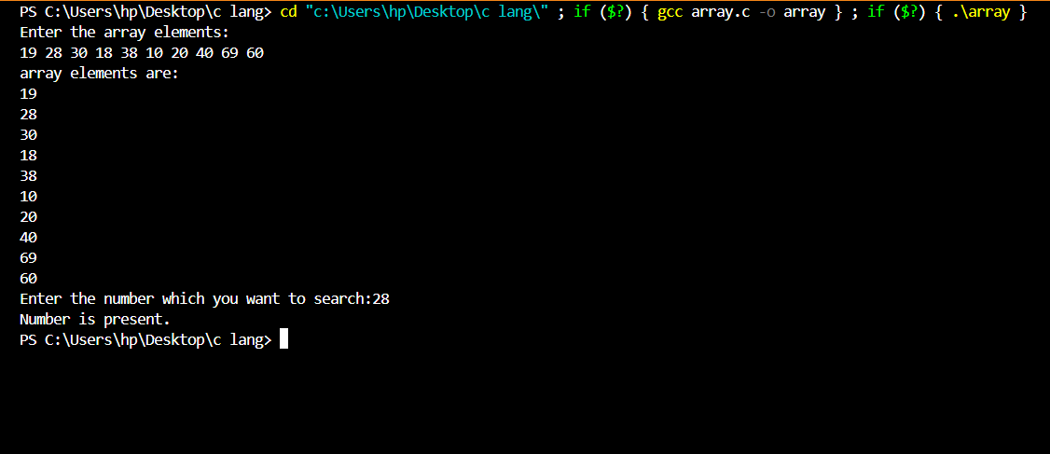

1. Create an array of size n and write a program to update some element of array as user choice:

#include<stdio.h>

void main()

{

int n,i,a[10],k,h;

printf("Enter the number of elements you want in an array:");

scanf("%d",&n);

printf("Enter the array elements:");

for(i=0; i<n; i++){

scanf("%d", &a[i]);

}

printf("Array elements are:");

for(i=0; i<n; i++){

printf("%d\n", a[i]);

}

printf("Enter the position to be updated:");

scanf("%d", &k);

printf("Enter the value to be updated:");

scanf("%d", &h);

for(i=0;i<n;i++){

if(i+1==k){

a[i]=h;

}

}

printf("Array after update:\n");

for(i=0;i<n;i++){

printf("a[%d]=%d\n",i, a[i]);

}

}

**Output:**

